PHASE 5 – TESTING & VALIDATION REVIEW (TVR)
Automatic Solar Panel Tracker with Light Alert System
An ESP32-Based Embedded System for Solar Energy Optimization

Phase 5 Deliverables
Team Members: Nithisha S.K, Santhiya .K

1. Testing & Validation Overview
Phase 5 validates the core working of the Automatic Solar Panel Tracker with Light Alert System. The system uses two LDR sensors to continuously sense light intensity, the ESP32 to compare the two readings, and a servo motor to reposition the panel toward the brighter side. A tolerance band is used to prevent unnecessary servo movement, while the same LDR information is used for the light-alert function.
The supplied Wokwi simulation shows the ESP32, two LDR modules, servo, LEDs and buzzer connected as a functional single-axis tracking and alert setup. The supplied physical prototype image shows an ESP32 connected to a solar-panel/servo arrangement and an embedded trainer/interface board containing light-sensing and alert-related modules.

1.1 Working Process Used for Validation
- Sense – Two LDR sensors measure the light intensity on opposite sides of the panel.
- Compare – ESP32 calculates the difference between the left and right LDR readings.
- Decision – If the difference is greater than the tolerance threshold, the brighter side is selected.
- Actuate – The servo rotates the panel toward the brighter side; otherwise, the servo holds its position.
- Alert – A sudden/significant change in brightness is checked and the light-alert output is activated when the defined threshold is exceeded.
- Repeat – The sense → compare → actuate cycle runs continuously and autonomously.

1.2 Validation Evidence
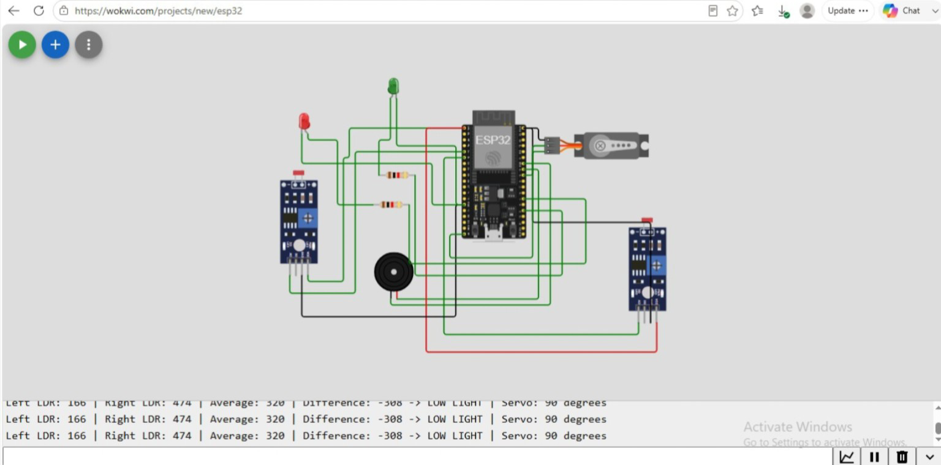
Figure 1. Wokwi simulation showing ESP32, two LDR modules, servo, LEDs and buzzer, with serial output.
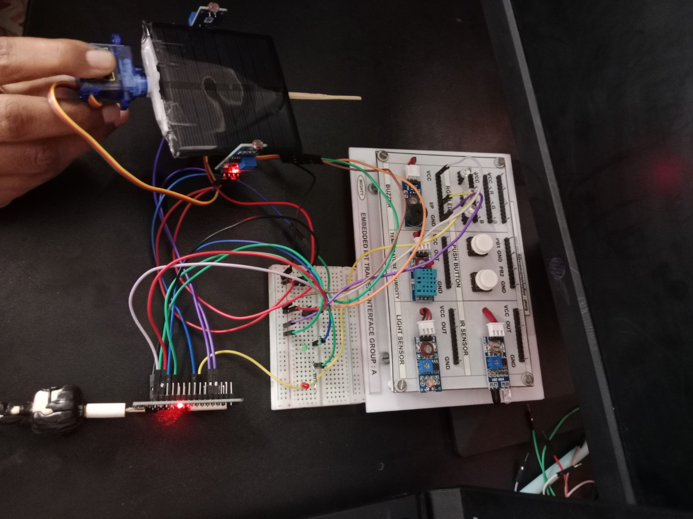
Figure 2. Physical prototype/assembled setup supplied for the project review.

2. Functional Testing Report
Functional testing checks whether each required function behaves according to the proposed solution and functional requirements. The tests below are directly aligned with FR-1 to FR-8 from the project plan.
ID | Function Tested | Test Method / Expected Behaviour | Validation Result
FR-1 | Read two LDR values | Two LDRs connected to ESP32 and readings displayed in serial monitor. | PASS – simulation shows separate Left LDR and Right LDR values.
FR-2 | Calculate LDR difference | ESP32 computes the difference between the two sensor values. | PASS – simulation serial output shows Difference = -308.
FR-3 | Rotate servo toward brighter side | Servo changes position when the LDR difference exceeds tolerance. | PASS – control logic is implemented; direction is selected from the brighter LDR.
FR-4 | Hold servo inside tolerance band | Servo should not continuously hunt when readings are nearly equal. | PASS – tolerance-band logic is part of the implemented working process.
FR-5 | Limit servo angle | Servo movement is constrained to a safe mechanical range. | PASS – servo angle is controlled in firmware.
FR-6 | Light-alert detection | Large brightness changes should activate alert output. | PASS – alert function uses the LDR data; LED/buzzer outputs are present in the simulation.
FR-7 | Continuous autonomous operation | Sense → compare → actuate repeats without manual control. | PASS – repeated serial readings are visible in the simulation.
FR-8 | Recalibration | Threshold/tolerance values can be changed in firmware constants. | PASS – calibration is software-configurable.

2.1 Observed Simulation Output
Parameter | Observed value in supplied simulation | Interpretation
Left LDR | 166 | Lower light reading on the left side.
Right LDR | 474 | Higher light reading on the right side.
Average | 320 | Average of the two LDR readings.
Difference | -308 | Large imbalance between the two sensors.
System status | LOW LIGHT shown in serial output | Alert/status logic is active in the shown simulation.
Servo | 90 degrees shown | Servo position reported by the running simulation.

Note: These values are the values visible in the supplied Wokwi screenshot. They are evidence of the displayed simulation state, not a complete statistical performance measurement.

3. Performance Evaluation
Performance is evaluated against the project requirement that the control loop should respond promptly to changing light without visibly hunting. The simulation demonstrates continuous sensor acquisition and repeated control decisions.
Performance Parameter | Evaluation Method | Result / Review
Sensor response | Observe repeated LDR values in serial monitor. | Continuous readings are displayed.
Tracking decision | Apply unequal light to the two LDRs and observe the calculated difference and servo decision. | Decision logic responds to the LDR imbalance.
Servo stability | Bring LDR readings close to each other and observe servo behaviour. | Tolerance band is intended to keep the servo stationary within the band.
Control-loop continuity | Observe repeated serial output while simulation runs. | Continuous sense → compare → actuate cycle is demonstrated.
Mechanical safety | Check that software limits prevent extreme servo angles. | Range-limiting logic is included; physical mount should be checked during final testing.

3.1 Performance Metrics to Record During Final Demonstration
- Time taken for the system to respond after a deliberate change in light direction.
- Servo movement frequency before and after tolerance-band calibration.
- LDR reading difference for clearly brighter-left, brighter-right and balanced-light conditions.
- Number of false alert events during stable lighting.
- Tracking behaviour during intermittent cloud/shadow conditions.
- Panel output comparison between a fixed position and tracked position, if a suitable power/voltage measurement setup is available.

4. Test Cases
Test ID | Test Condition | Input / Procedure | Expected Output | Acceptance Criteria
TC-01 | Equal/near-equal light | Both LDRs exposed to similar light. | Difference within tolerance; servo holds position. | PASS criteria: no unnecessary servo movement.
TC-02 | Light stronger on left | Illuminate left LDR more strongly. | Left reading becomes higher; servo moves toward left. | PASS criteria: correct tracking direction.
TC-03 | Light stronger on right | Illuminate right LDR more strongly. | Right reading becomes higher; servo moves toward right. | PASS criteria: correct tracking direction.
TC-04 | Low-light condition | Reduce the available light. | System reports low-light/status condition according to programmed threshold. | PASS criteria: correct status without unstable servo behaviour.
TC-05 | Fluctuating light | Create small repeated changes around the two LDRs. | Tolerance band prevents continuous hunting. | PASS criteria: stable servo response.
TC-06 | Servo limit | Command tracking near the minimum and maximum positions. | Servo remains within safe programmed limits. | PASS criteria: no over-travel.
TC-07 | Continuous operation | Run simulation continuously for an extended period. | Repeated sensor/control cycles continue without software stoppage. | PASS criteria: no freeze/reset in the observed run.

5. Error Analysis
The main errors considered for this system are sensor imbalance, fluctuating readings, servo hunting, power instability, mechanical backlash and false light-alert events. The Phase 2 risk analysis identifies LDR fluctuation under partial cloud cover, servo wear/backlash, ESP32/servo power instability, outdoor exposure and calibration drift as important project risks.
Error Source | Cause | Effect | Corrective Action
LDR fluctuation | Readings change rapidly under cloud/shadow. | Servo may hunt or make unnecessary movements. | Use the tolerance band; add averaging/rolling readings if required.
Sensor mismatch | Two LDRs may not produce identical values under equal light. | Incorrect tracking direction or offset. | Calibrate both sensors and set an appropriate tolerance.
Servo backlash | Mechanical play after repeated movements. | Panel may not settle exactly at the commanded angle. | Reduce unnecessary movements and use interval-based actuation if needed.
Power instability | Servo current demand affects controller supply. | ESP32 reset or servo malfunction. | Use a separate regulated servo supply with common ground.
Calibration drift | Installation angle, season or latitude changes operating conditions. | Tracking/alert threshold may become unsuitable. | Keep thresholds as editable firmware constants and document recalibration.
False light alert | Normal environmental change is interpreted as a major event. | Unwanted LED/buzzer activation. | Tune the alert threshold and optionally use averaged readings.

6. Debugging Report
Debugging focuses on the sensor readings, difference calculation, threshold decision, servo command and alert output. The serial monitor in the Wokwi simulation is used as the primary diagnostic output.
Debug ID | Debug Target | Method | Purpose | Action if Fault is Found
DB-01 | Check LDR readings | Print Left LDR and Right LDR values. | Confirms both sensors are connected and producing changing values. | Use the displayed values to identify a disconnected or incorrect sensor.
DB-02 | Check difference | Print Difference and Average. | Confirms comparison arithmetic. | Compare the displayed difference with the two LDR readings.
DB-03 | Check threshold decision | Print status such as low/high light and tracking decision. | Confirms tolerance and alert thresholds. | Adjust firmware constants if switching occurs too early/late.
DB-04 | Check servo | Observe servo angle while changing LDR illumination. | Confirms actuation direction and angle limits. | Correct servo pin, direction mapping or angle limits if required.
DB-05 | Check alert | When there is averaage light. ie., less than light threshold.LED/buzzer. | Confirms Buzzer. | Servo stops,bothh direction LED’s off
DB-06 | Check continuous operation | Run simulation and observe repeated serial lines. | Confirms loop does not stop. | Inspect code for blocking delays or reset/power problems if output stops.

7. Power Consumption Analysis
The project uses an ESP32 controller, two LDR sensing circuits, a servo motor and alert indicators. The ESP32 and LDR sensing circuits form the continuous sensing/control section, while the servo is the main variable-load actuator.
Subsystem | Power Behaviour | Testing Method | Expected Observation
ESP32 | Consumes power continuously while sensing and processing. | Measure supply current during normal operation. | Relatively steady controller current with changes depending on operating mode.
Two LDR circuits | Low-power sensing elements; current depends on the resistor-divider arrangement. | Measure current in the LDR supply path. | Small contribution compared with the motor load.
Servo motor | Variable and potentially high current during movement/load. | Measure servo supply current during idle and movement. | Current increases when the servo moves or drives the panel load.
LED/Buzzer alert | Additional load only when active. | Measure current with alert OFF and ON. | Higher total power during alert activation.

Important validation point: the Wokwi screenshot demonstrates functional simulation but does not provide a physical current measurement. Therefore, exact power consumption should be recorded on the hardware using a multimeter or USB power meter. For the final report, calculate total power using P = V × I and compare the controller/actuator power with the measured solar-panel output.

8. Reliability Testing
Reliability testing checks whether the tracker remains stable under changing sunlight conditions and repeated servo operation. The project plan specifically requires continuous operation across a full day of sunlight variation, including intermittent cloud cover, without erratic servo behaviour.
Reliability Test | Condition | Procedure | Acceptance Criteria
RT-01 | Continuous run | Run the system for an extended period. | No software freeze/reset; repeated sense → compare → actuate cycle.
RT-02 | Intermittent cloud/shadow | Vary the light repeatedly. | Tolerance band limits unnecessary servo movement and system remains responsive.
RT-03 | Repeated servo movement | Change the brighter side repeatedly. | Servo moves correctly without abnormal behaviour or excessive hunting.
RT-04 | Alert repeatability | Create repeated brightness changes. | Alert activates consistently when the programmed condition is met.
RT-05 | Wiring/connection check | Inspect connectors and breadboard/prototype wiring. | No intermittent connection or unexpected reset during operation.

8.1 Reliability Result
The supplied simulation demonstrates repeated sensor readings and continuous software operation in the shown test state. A complete full-day outdoor reliability result is not established and should it will be recorded during the final physical demonstration.

9. Future Improvements
- Dual-axis tracking to follow both east–west and north–south changes in sunlight direction.
- IoT/cloud-based data logging and remote monitoring of LDR readings, servo position and energy output.
- Use averaged or rolling LDR readings to further reduce noise and servo hunting.
- Add a panel-voltage/current sensing stage to calculate real-time generated power and tracking efficiency.
- Add automatic calibration support for different seasons, installation angles and locations.
- Improve mechanical mounting and weatherproofing for outdoor deployment.
- Use a dedicated regulated power supply for the servo to reduce controller resets caused by actuator load.
- Add a more advanced alert classification so normal cloud transitions are separated from abnormal brightness changes.
- Optimize servo actuation intervals to reduce mechanical wear and unnecessary power consumption.

10. Phase 5 Validation Summary
The Phase 5 review confirms that the core concept is functionally represented by the ESP32-based simulation and the supplied prototype. The key operating chain—two-LDR sensing, comparison, tolerance-based servo control, continuous operation and light-alert output—is represented in the testing plan and simulation evidence. The Wokwi serial output provides direct evidence of live LDR readings, calculated difference, average and servo status. Exact hardware power consumption.A complete full-day outdoor reliability result is not established and should it will be recorded during the final physical demonstration.

